BUDDY LITE
General Info:
- Infuses by gravity (does NOT control flow rate)
- Heats blood and/or fluids to 38 degrees Celsius (100.4 degrees F)
  - Heats crystalloids at 20 degrees Celsius up to 80ml/min
  - Heats PRBCs at 10 degrees Celsius up to 50ml/min
  - You can infuse faster than these rates, but fluid may not be fully warmed
- Rechargeable battery; docking station in the nursing office to charge
Instructions for use:
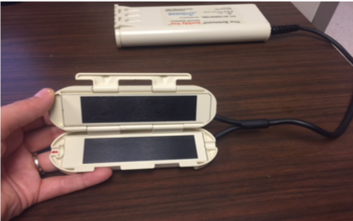
- Open heater unit door

2. Line up orientation hub on the disposable set with the notch in the heater unit (red to red)
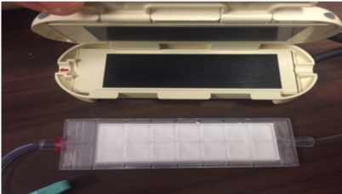
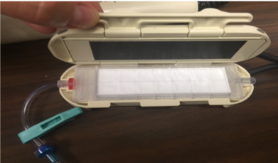
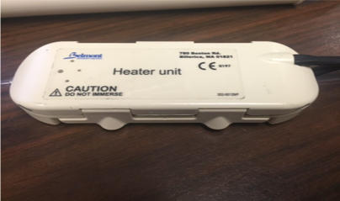
3. Close door and secure the latch

4. Attach the disposable set to the IV administration set (red capped end, red to blood) and prime as you normally would, then hook up to patient (blue capped end, blue to you)
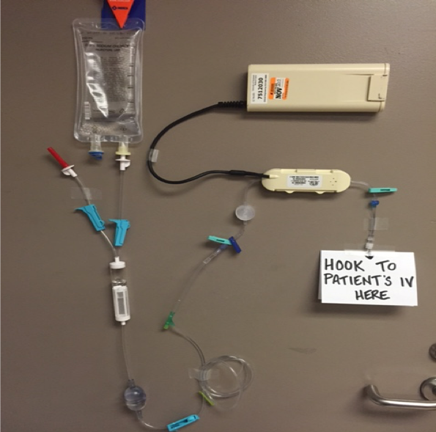
5. Press the “ON” button and begin infusing
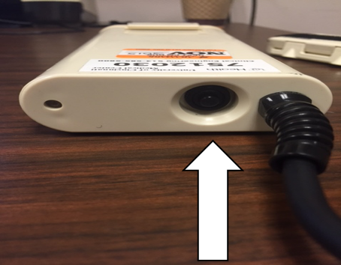
6. Don’t forget to watch the battery life…and remove and dock on charger if needed
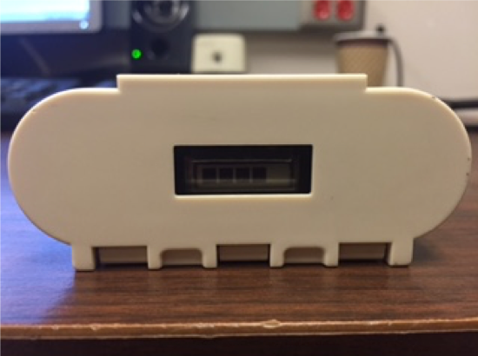

Source:
Air Care Equipment — Taming the SRU

